[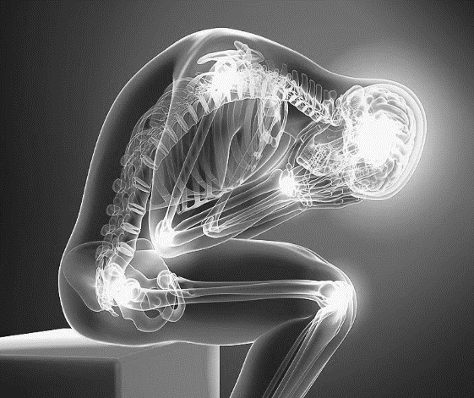](https://www.google.ca/url?sa=i&rct=j&q=&esrc=s&source=images&cd=&ved=2ahUKEwjrgt-P_ZbjAhWQwMQHHZ-cDyQQjRx6BAgBEAU&url=https://twfht.ca/displayPage.php?event=17&psig=AOvVaw29a0OCZShBR-U58jby9ozX&ust=1562182400575418)

**REFERENCES:**

1. Hylands-White, N, et al. (2017). An overview of treatment approaches for chronic pain management. *Rheum Intnl, 37*, 29-42.
2. Kress, H, et al. (2015). A holistic approach to chronic pain management that involves all stakeholders: Change is needed. *Current Medical Research Opinion, 31*(9), 1743-1754.
3. Buchwald, D, et al. (2000). Use of traditional health practices among Native Americans in a primary care setting. *Medical Care, 38*(12), 1191-1199.

**KEY POINTS**

* Chronic pain is influenced by factors outside the realm of biomedicine
* A biopsychosocial approach allows social and psychological aspects of chronic pain to be incorporated as well as the traditional biomedical view
* Using a broader approach to chronic pain will allow for more accurate assessment, diagnosis and treatment (including the use of traditional and alternative medicines)
* The goal of chronic pain treatment must focus on improving overall well-being and function, not just pain relief

0

Highlights:

* Pain management is often considered a low priority by HCPs and is under-resourced
* Chronic pain is a medical condition in its own right
* Multidisciplinary biopsychosocial approaches are needed and barriers could be addressed by improving education at the undergraduate and postgraduate levels

Highlights:

* Pain is a multidimensional health problem that requires an equally multifaceted explanation and treatment approach
* Treatment requires a combination of biological and psychosocial approaches
* Biopsychosocial approaches provide a broader scope of inquiry than traditional biomedical approaches as they allow treatment to address functional ability and overall well-being, as well as physical pain relief

**1**

**2**

**3**

***THEME:***

***RECONCEPTUALIZING PAIN***

Highlights:

* Patients often express preference for traditional healing practices (THP) for pain-related conditions
* THP are often used to treat pain of indeterminate origin
* Patients conceptualize traditional healing as treating the underlying causes (usually of spiritual nature) rather than just acute symptoms
* THP with biomedical practices treats both the underlying causes and the acute symptoms of pain

**Selected Studies**

The concept of chronic pain must be broadened to include the biopsychosocial aspects of pain, as well as the traditional biomedical view. Chronic pain must be understood as a disease rather than a symptom of an associated condition.

**OPIOID PRESCRIBING PROJECT**

**LITERATURE SUMMARY SHEET**