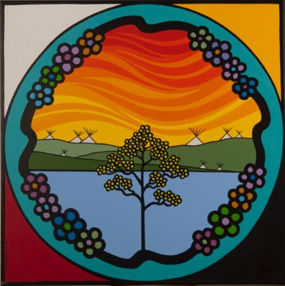

**REFERENCES:**

1. Fenwick, C. (2006). Assessing pain across the cultural gap: Central Australian Indigenous peoples’ pain assessment. *Contemp Nurse, 22*(2), 218-227.
2. Johnson-Jennings, M, et al. (2015). The healing relationship in Indigenous patients’ pain care: Influences of racial concordance and patient ethnic salience on healthcare providers’ pain assessment. *International Journal of Indign Health, 10*(2), 33-50.
3. Jimenez, N, et al. (2011). A review of the experience, epidemiology, and management of pain among American Indian, Alaska Native, and Aboriginal Canadian peoples. *Journal of Pain, 12*(5), 511-522.

***THEME:***

***INDIGENOUS EXPRESSIONS OF PAIN***

**KEY POINTS**

* Pain assessment frequently occurs in a bicultural space with the potential for misunderstanding, power imbalances, and inequity
* Pain assessment is dependent upon patients effectively communicating their pain and HCPs accurately interpreting these expressions
* Misunderstandings regarding pain can negatively impact the patient-provider relationship and interfere with clinical assessment, diagnosis, and treatment
* Expressions of pain carry social, cultural, political and historical undertones

Differences in social, cultural, and political backgrounds produce variations in the expressions of pain across ethnic groups. Indigenous peoples do not express pain in the same manner as non-Indigenous peoples due to cultural variances, as well as past and present experiences with the healthcare system that are rooted in colonization. In bicultural clinical encounter settings, this variation in expression of pain results in miscommunication and inappropriate treatment of chronic pain in Indigenous populations.

**1**

**2**

**3**

**Selected Studies**

Highlights:

* Indigenous patients use patterns of medical communication that are different from non-Indigenous patients (e.g. under-emphasis of pain and disability)
* MDs are more likely to discredit an Indigenous patient’s pain when pain medication is requested than for non-Indigenous patients
* Pain is conceptualized as a broader sense of well-being between the mind, body, spirit and emotions

Highlights:

* Indigenous peoples often have unique and subtle expressions of pain
* Discussions of pain may contain elements of politics and spirituality due to histories of lost lands, stolen generations, and connection to the environment and community
* The continuing effects of colonization mean Indigenous peoples may suppress or be reluctant to share pain to avoid displaying vulnerability

Highlights:

* Culturally appropriate pain care for Indigenous patients may be impeded by historical and current barriers in the healthcare system
* Cultural differences mean that non-Indigenous HCPs may have difficulties assessing Indigenous cultural expressions of pain, which subsequently impacts treatment
* Indigenous health frameworks highlight the holistic and relational aspects of healing (respect, connection, trust and spirituality)

**OPIOID PRESCRIBING PROJECT**

**LITERATURE SUMMARY SHEET**